Lab xx: Cisco IOS XE NETCONF API







IOS XE NETCONF

In this Exercise you will use the NETCONF protocol to edit the configuration on the IOS XE router.

As the NETCONF protocol only uses XML, the protocols JSON and REST are not applicable. Postman has no value with NETCONF. NETCONF is designed to allow remote configuration of a device with the YANG mode.

Extensible Markup Language, or XML, is a standard maintained by the World Wide Web Consortium (W3C) that defines a syntax that lets you create markup languages to specify information structures. Information structures define the type of information. External processes can manipulate these information structures and publish them in a variety of formats. While XML allows you to define your own customized markup language, Cisco has created all the XML definitions for Cisco products.

Task 1: NETCONF on IOS XE initial configuration.

In this task you will configure the commands to enable **NETCONF** on your CSR1000v.

How-to Steps

1. Starting from your login page on Remotelabs.com as described in Lab 0, click on **Connect via Topology**.

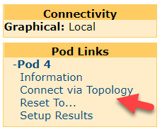

1. The lab topology diagram will open. Notice how you can hover your mouse over the individual computers to see which you can connect into directly form the web portal.

|  |
| --- |
| NOTE_CALLOUT |
| In this Global Knowledge lab environment, you can open any of the virtual machines with a “hot link,” but you can have only one VM open at any one time. Opening a second VM will close the first connection you were in, without losing any of your settings or internal network connections. |

1. Ensure these Python labs have been done first: 11, 12, 13, 14
2. Connect to your **Ubuntu Configured** VM.
3. Add some configuration into the IOS XE router.
4. Open a Terminal widow.
5. Type in the command to connect to your CSR router with netconf

ssh -p 830 admin@192.168.10.80 -s netconf

1. Respond with a **yes** if prompted about an RSA key. (you will likely not be prompted for later ssh sessions)

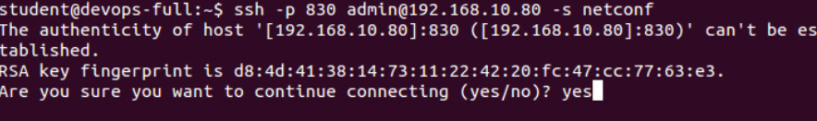

1. Enter the password **cisco** when prompted. Note all the XML output of this device capabilities.
2. Enter in this exact XML code directly after the NETCONF prompt. This is stating your NETCONF client capabilities.

<?xml version="1.0" encoding="UTF-8"?>

<hello xmlns="urn:ietf:params:xml:ns:netconf:base:1.0">

<capabilities>

<capability>urn:ietf:params:netconf:base:1.0</capability>

</capabilities>

</hello>]]>]]>

Note: Additional capabilities can be entered above obtained from the NETCONF device during the initial capabilities exchange.

1. You can hit enter a few times. Note how you don’t have a left indented prompt at this point.

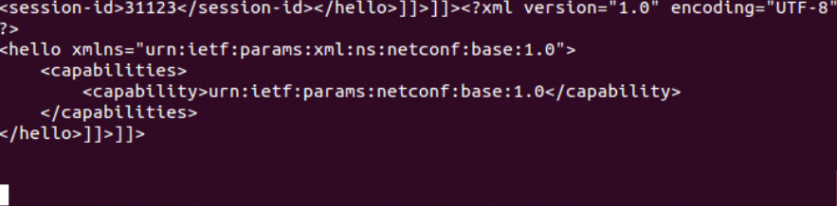

1. Maximize your window.
2. To get the entire device config in XML, enter in this entire NETCONF get command:

<?xml version="1.0"?>

<nc:rpc message-id="101" xmlns:nc="urn:ietf:params:xml:ns:netconf:base:1.0">

<nc:get>

<nc:filter type="subtree">

<native xmlns="http://cisco.com/ns/yang/ned/ios">

</native>

</nc:filter>

</nc:get>

</nc:rpc>

]]>]]>

1. Copy the entire XML output code starting right after the NETCONF prompt to the very end excluding the trailing NETCONF prompt:

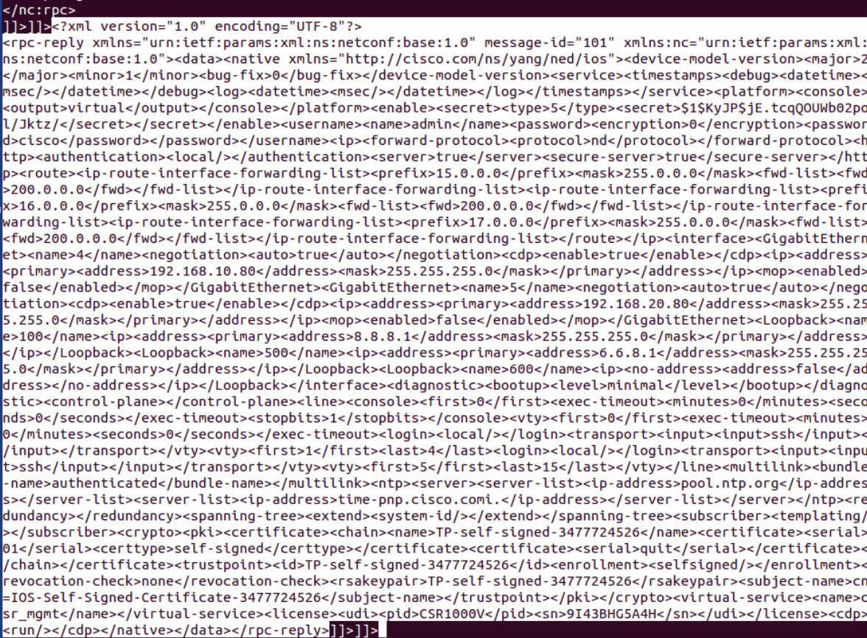

1. Go to

<https://xmlvalidator.com>

<https://www.webtoolkitonline.com> formatter xml

1. Ensure that the XML is validated.
2. Paste the XML into Sublime. You now have a configuration of your IOS XE device in properly formatted XML.
3. Save the file as iosxe.xml to your Class_Share directory.
4. Open Win7 VM and open the iosxe.xml file
5. In Pycharm, open

xe_nc_configure_interface.py

1. Change line 8 for the credentials
2. Q



Challenge results

This lab demonstrated editing the configuration of an IOS XE device with Python using Netconf.